Name: Felix Kiprono Bett

Peer Group 2

**QUESTION ONE (1)**

**-- How many users does Wave have?**

CREATE DATABASE wave_money_transfer;

USE wave_money_transfer;

SELECT * FROM users;

SELECT COUNT(u_id) AS WAVE_USERS

FROM users;

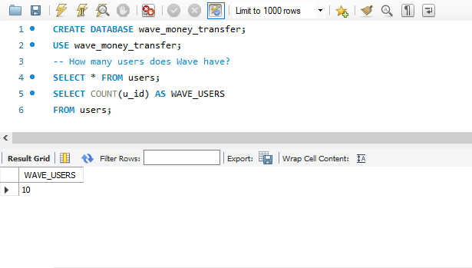

**QUESTION TWO (2)**

**-- How many transfers have been sent in the currency CFA?**

SELECT * FROM transfers;

SELECT COUNT(transfer_id) AS CFA_TRANSFERS

FROM transfers

WHERE send_amount_currency LIKE '%CFA%';

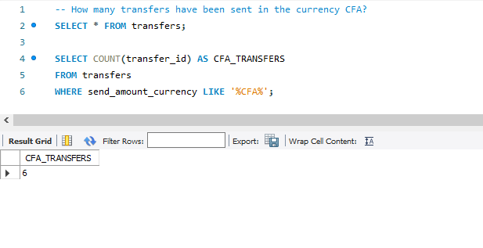

**QUESTION THREE (3)**

**-- How many different users have sent a transfer in CFA?**

SELECT COUNT(DISTINCT user_id) AS USERS_CFA_TRANSFERS

FROM transfers

WHERE send_amount_currency LIKE '%CFA%';

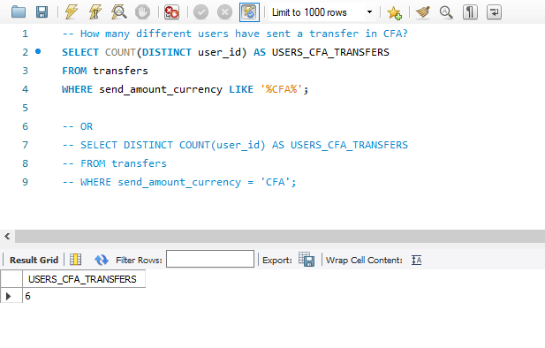

**QUESTION FOUR (4)**

**-- How many agent_transactions did we have in the months of 2022 (broken down by month)?**

SELECT SUBSTR(when_created,4,2) AS Month, COUNT(atx_id) AS 'No. of Agent Transactions'

FROM agent_transactions

WHERE SUBSTR(when_created,7,4) = 2022

GROUP BY SUBSTR(when_created,4,2)

ORDER BY SUBSTR(when_created,4,2);

**QUESTION FIVE (5)**

**-- Over the course of the first half of 2022,**

**-- how many Wave agents were "net depositers" vs "net withdrawers"?**

SELECT

CASE

WHEN total < 0 THEN 'Net Depositors'

ELSE 'Net withdrawers'

END AS AgentType,

COUNT(*) AS Agents FROM (SELECT agent_id, SUM(amount) AS Total

FROM agent_transactions

WHERE when_created BETWEEN '01/01/2022' AND '30/06/2022'

GROUP BY 1) sub

GROUP BY 1;

**QUESTION SIX (6)**

**-- Build an "atx volume city summary" table:**

**-- find the volume of agent transactions created in the first half of 2022, grouped by city.**

**-- You can determine the city where the agent transactions took place from the agent's city field.**

SELECT a.city, SUM(ABS(at.amount)) AS volume

FROM agent_transactions at

JOIN agents a ON at.agent_id = a.agent_id

WHERE at.when_created BETWEEN '01/01/2022' AND '30/06/2022'

GROUP BY 1;

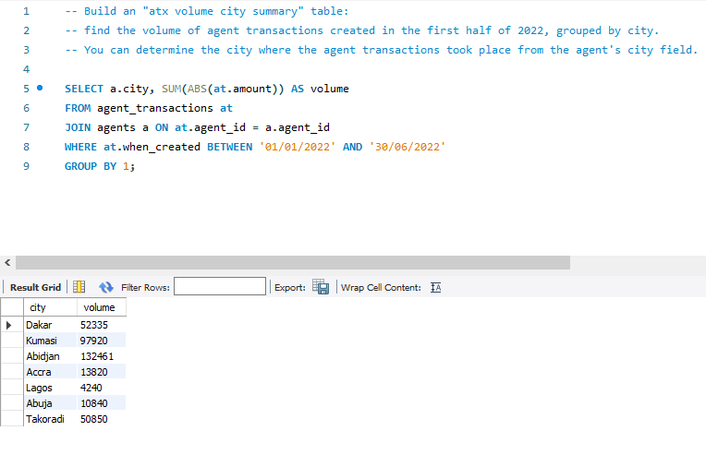

**QUESTION SEVEN (7)**

**-- Now separate the atx volume by country as well (so your columns should be the country, city, volume).**

SELECT a.country, a.city, SUM(ABS(at.amount)) AS volume

FROM agent_transactions at

JOIN agents a ON at.agent_id = a.agent_id

WHERE at.when_created BETWEEN '01/01/2022' AND '30/06/2022'

GROUP BY 1, 2;

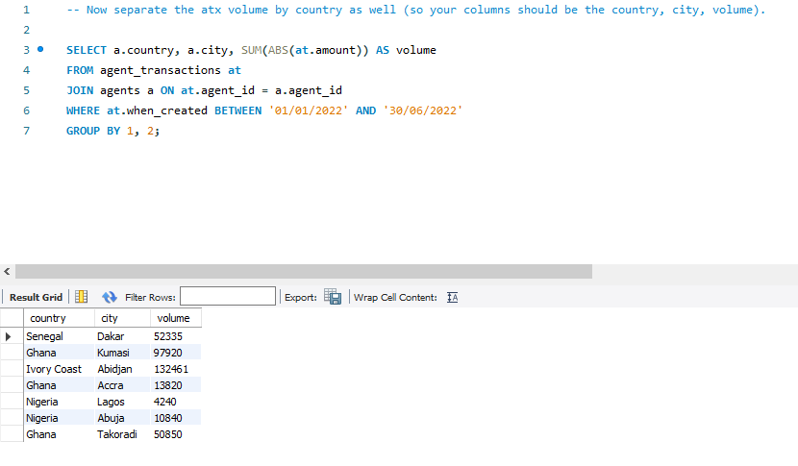

**QUESTION EIGHT (8)**

**-- Build a "send volume by country kind" table:**

**-- find the total volume of transfers (by send_amount_scalar)**

**-- sent in the first half of 2022, grouped by country and transfer kind.**

SELECT w.ledger_location AS country, t.kind, SUM(t.send_amount_scalar) AS volume

FROM transfers AS t

JOIN wallets AS w ON t.source_wallet_id = w.wallet_id

WHERE t.when_created BETWEEN '01/01/2022' AND '30/06/2022'

GROUP BY 1, 2;

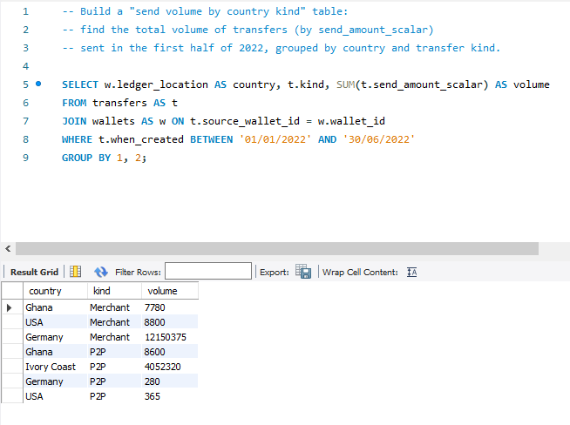

**QUESTION NINE (9)**

**-- Then add columns for transactions count and number of unique senders**

**-- (still broken down by country and transfer kind).**

SELECT w.ledger_location AS country, t.kind, SUM(t.send_amount_scalar) AS volume,

COUNT(*) AS transactions, COUNT(DISTINCT user_id) AS 'unique users'

FROM transfers t

JOIN wallets w ON t.source_wallet_id = w.wallet_id

WHERE t.when_created BETWEEN '01/01/2022' AND '30/06/2022'

GROUP BY 1, 2

ORDER BY 1;

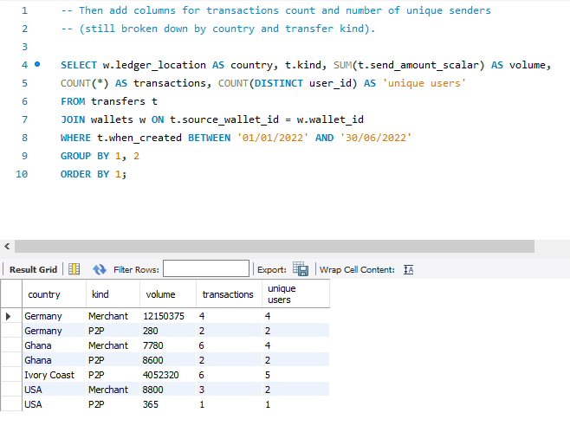

**QUESTION TEN (10)**

**-- Finally, which wallets sent more than 1,000,000 CFA in transfers in the first quarter**

**-- (as identified by the source_wallet_id column on the transfers table) and how much they send?**

SELECT source_wallet_id AS Wallets, SUM(send_amount_scalar) AS 'Amount Sent'

FROM transfers

WHERE send_amount_currency = 'CFA'

AND (when_created BETWEEN '01/01/2022' AND '31/03/2022')

GROUP BY 1

HAVING SUM(send_amount_scalar) > 1000000;

